CHINO BACKSHOPS
CAN MOTOR RE-POWER KITS

KIT#8 HO SCALE HOBBYTOWN RS3 and RSD5 ROADSWITCHERS

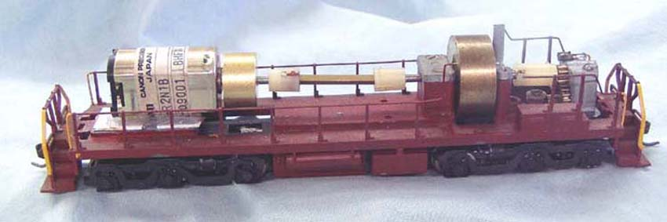
KIT INCLUDES:

1 FLAT CAN MOTOR, 1 FLYWHEEL w/shaft extension
MOTOR SPECS:
12VDC 50ma 6800rpm
1.3” X 0.865” X 0.715” 33mm X 22mm X 18mm
2mm shaft, 8mm long
Stall current 800ma

FLYWHEEL
0.687” diameter, 0.398” wide 17mm x 10mm
2mm shaft bore, 8mm x 2.4mm shaft extension

Photo shows kit installed on a Hobbytown RSD4 chassis
(not included)

