CHINO BACKSHOPS
CAN MOTOR RE-POWER KITS

KIT#7 HO SCALE AHM-RIVAROSSI ARTICULATED STEAM LOCOMOTIVES
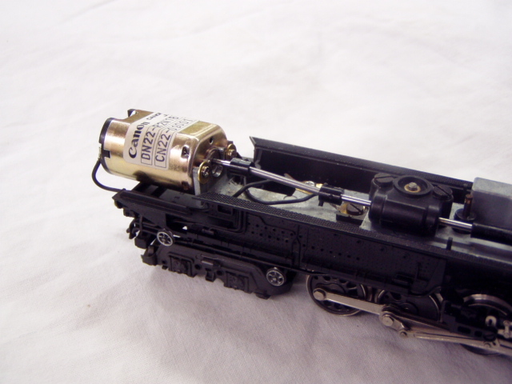

KIT INCLUDES:

1 FLAT CAN MOTOR, METAL DRIVE SHAFT, COUPLINGS, MOUNTING HARDWARE
ILLUSTRATED INSTALLATION INSTRUCTIONS

MOTOR SPECS:
12VDC 50ma 6800rpm
1.3” x 0.865” X 0.715” 32mm X 22mm X 18mm
2mm shaft, 8mm long

THE PHOTO SHOWS THE MOTOR KIT INSTALLED ON A
HO SCALE RIVAROSSI BIG BOY CHASSIS (NOT INCLUDED WITH KIT)
This kit will work on all Rivarossi articulated steam locos

