CHINO BACKSHOPS
CAN MOTOR RE-POWER KITS

KIT#6 HO SCALE SMALL BRASS LOCOMOTIVES

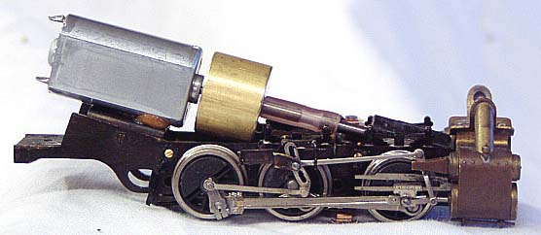

KIT INCLUDES:

1 FLAT CAN MOTOR, FLEXIBLE COUPLING, AND FLYWHEEL

MOTOR SPECS:
12VDC 48ma 5500rpm
1.04” X 0.461” X 0.619” 27mm X 12mm X 16mm
1.5mm shaft, 10mm long

FLYWHEEL
0.625” DIAMETER, 0.500” LONG
16mm X 13mm

THE PHOTO SHOWS THE MOTOR KIT INSTALLED ON A
HO SCALE NWSL 2-6-2T CHASSIS (NOT INCLUDED WITH KIT)
This kit fits brass 0-4-0 to 2-8-0 steam locomotives
and
brass diesel switchers

