CHINO BACKSHOPS
CAN MOTOR RE-POWER KITS

KIT#5 HO SCALE AHM-RIVAROSSI STEAM LOCOMOTIVES or AHM GE U25C DIESEL
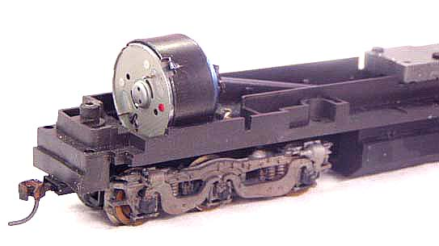
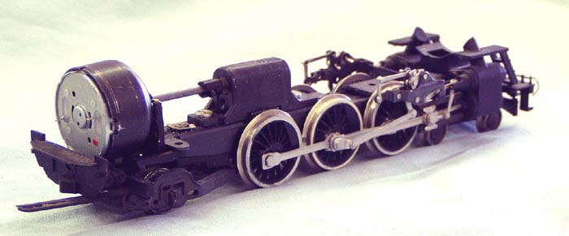

KIT INCLUDES:

1 ROUND CAN MOTOR, UNIVERSAL COUPLINGS, METAL DRIVE SHAFT AND ILLUSTRATED INSTALLATION INSTRUCTIONS

MOTOR SPECS:
12VDC 68ma 6800rpm
0.962” X 0.488” 24mm X 12mm
2mm shaft, 5mm long
800ma STALL CURRENT

THE PHOTO SHOWS THE MOTOR INSTALLED ON A
RIVAROSSI PACIFIC AND GE U25C CHASSIS (NOT INCLUDED WITH KIT)
THIS MOTOR MOUNTS INSIDE THE RIVAROSSI MOTOR CASE

Please note: This kit is intended for locomotive versions that have the round AHM motor mounted horizontally in the cab.
This kit fits 2-8-2 2-8-4 2-10-2 4-6-2 4-6-4 4-8-4

