CHINO BACKSHOPS
CAN MOTOR RE-POWER KITS

KIT#4 HO SCALE SUYDAM BRASS TRACTION MODELS
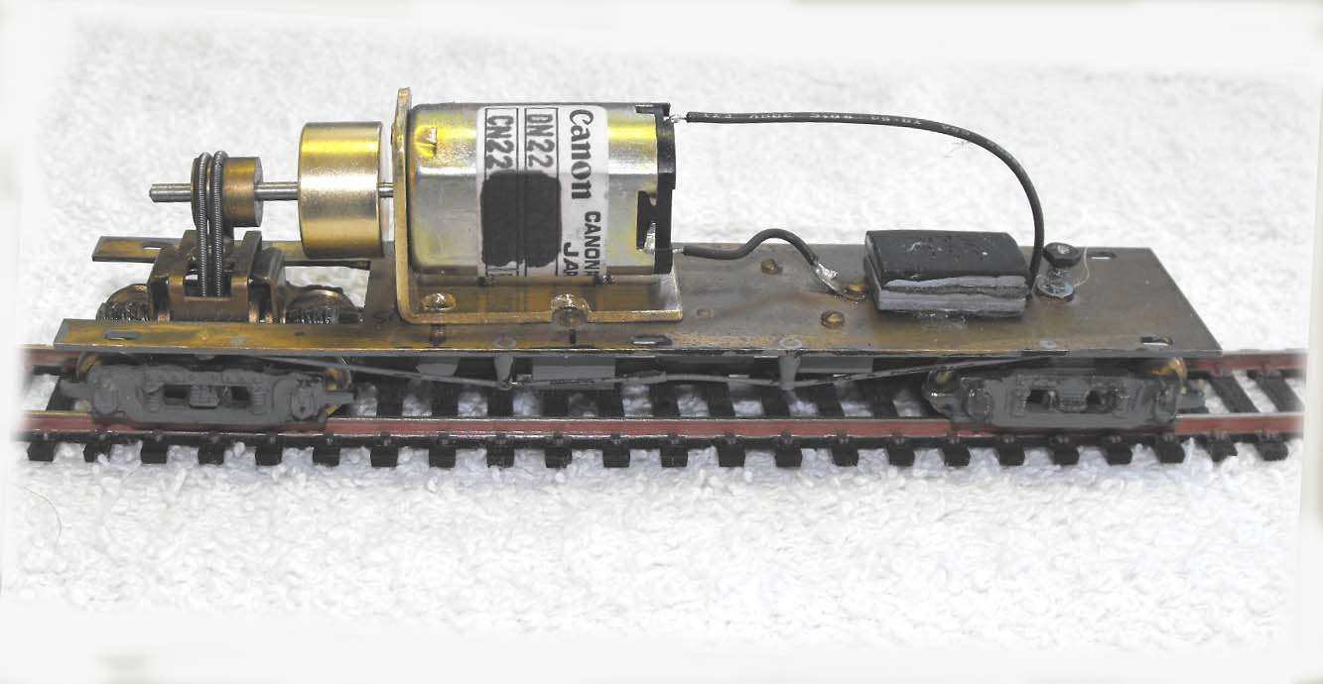

KIT INCLUDES:

1 FLAT CAN MOTOR WITH FLYWHEEL, SHAFT EXTENSION
and MOTOR MOUNTING TEMPLATE

MOTOR SPECS:
12VDC 50ma 6800rpm
1.3” X 0.865” X 0.0.715” 33mm X 22mm X 18mm
2mm shaft, 8mm long

FLYWHEEL
0.687” X 0.398” 17mm X 10mm
3/32” x 1” shaft extension

THE PHOTO SHOWS THE MOTOR KIT INSTALLED ON A
SUYDAM INTERURBAN CHASSIS (NOT INCLUDED WITH KIT)

