CHINO BACKSHOPS
CAN MOTOR RE-POWER KITS

KIT#13 HO SCALE MANTUA ARTICULATED
2-6-6-2 or 2-6-6-2T

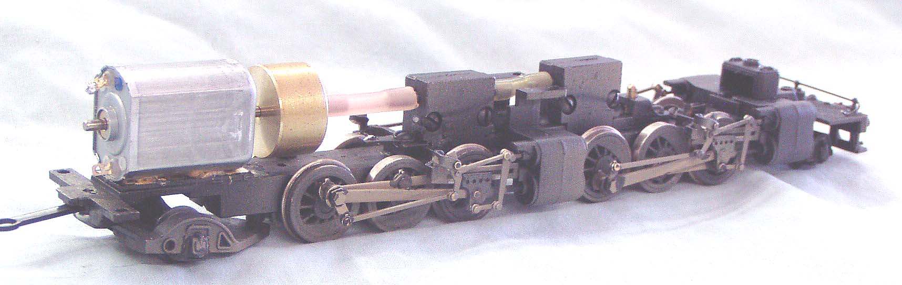
KIT INCLUDES:

1 FLAT CAN MOTOR WITH FLYWHEEL, FLEXIBLE COUPLING, MOUNTING PAD, AND ILLUSTRATED INSTALLATION INSTRUCTIONS

MOTOR SPECS:
SIZE 25mm X 20mm X 15mm
SHAFT 10mm X 2mm
VOLTAGE 12VDC
RPM 7800
CURRENT 58ma
STALL CURRENT 800ma

FLYWHEEL
0.687” x 0.398” 17.5mm x 10mm

THE PHOTO SHOWS THE MOTOR INSTALLED ON
A MANTUA 2-6-6-2 CHASSIS (NOT INCLUDED WITH KIT)

